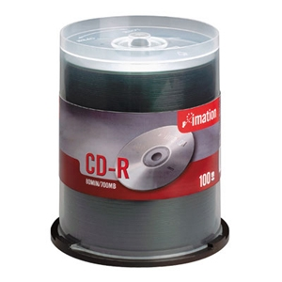

Imation 52X Certified 700MB CD-R 100PK Spindle
Whether it's music mastering, multimedia production or digital imaging, Imation CD-R discs store data swiftly and permanently with write speeds up to 52X, and cannot be erased or overwritten. Imation CDs have a high-quality dye layer test that ensures lower failure rates and an enhanced dye layer for maximum data reliability and longevity. Ideal for storing digital movies, customizing music mixes, saving digital photos, document imaging, data exchange, storing digital video creations and computer data
Specifications:

Format | CD-R
Capacity | 700MB
Record Time | 80 Minutes Audio
Write Speed | 52x
Quantity | 100 Discs
Packaging | Spindle

