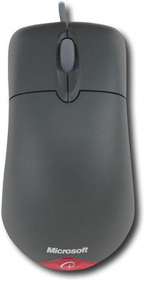

Microsoft Wheel Mouse Optical
Model: D66-00069

This reliable optical mouse features a convenient scroll wheel and comfortable design.

Optical sensor for smooth, precise movement on virtually any surface
Wheel function provides easy navigation of large documents and Web pages
Fits comfortably in right or left hand

Warranty Terms – Parts 1 year

Scrolling Wheel:
Yes

Optical Technology:

Yes
Left/Right-Handed Design

Ambidextrous

Cordless/Wireless:
No

Type of Pointing Device Optical mouse
Port Connection
USB or PS/2

System Requirements
Windows 98, NT Server 4.0 (with SP6 or later), 2000, ME, XP; Macintosh with Mac OS 8.6 or 9.x, Mac OS 10.1 (excluding 10.0); USB or PS/2 port; CD-ROM drive

